Vypinaní LEDky a podle spinace

BREADBOARD
http://sourceforge.net/p/raspberry-gpio-python/wiki/Examples/
http://raspi.tv/2013/how-to-use-interrupts-with-python-on-the-raspberry-pi-and-rpi-gpio-part-3
http://makezine.com/projects/tutorial-raspberry-pi-gpio-pins-and-python/

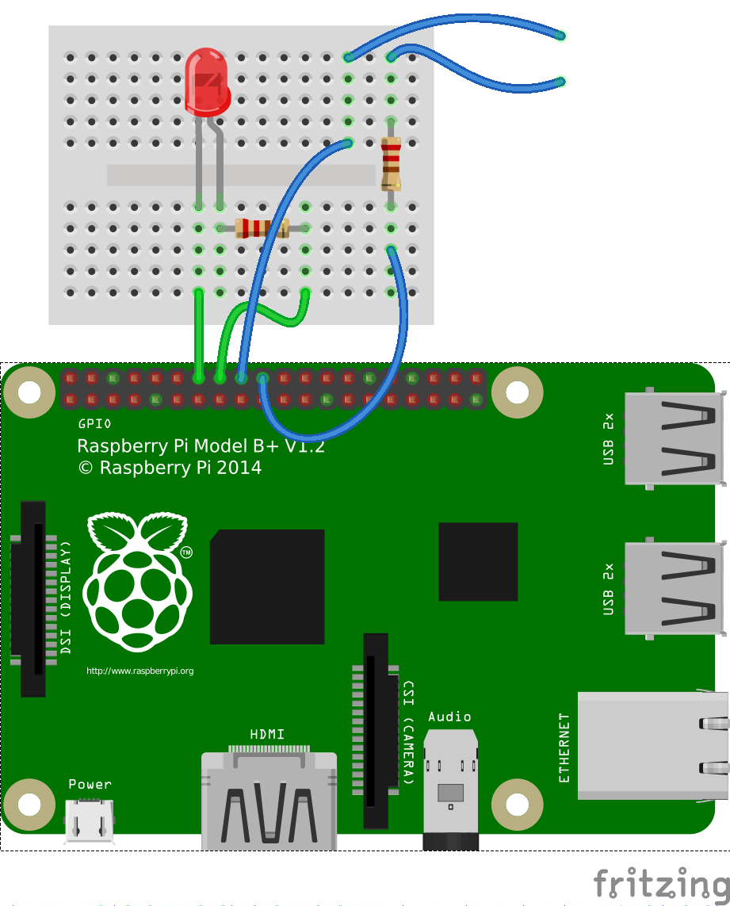

RASPI

SPINAC.PY

import RPi.GPIO as GPIO ## Import GPIO library
import time
GPIO.setmode(GPIO.BOARD) ## Use board pin numbering
GPIO.setup(18, GPIO.IN, pull_up_down=GPIO.PUD_UP)
GPIO.setup(16, GPIO.OUT) ## Setup GPIO Pin 16 to OUT
while 1:
if GPIO.input(18):
print "Nic se nedeje"
GPIO.output(16, False)
time.sleep(0.2)
else:
# When the button switch is not pressed, turn off the LED.
print "Nekdo prisel, svitime!"
GPIO.output( 16, True)
time.sleep(0.2)

Ale co víc spínačů?
(žlutej na žlutej!!!! červenej na červenej!!!!)

SPINAC2.PY
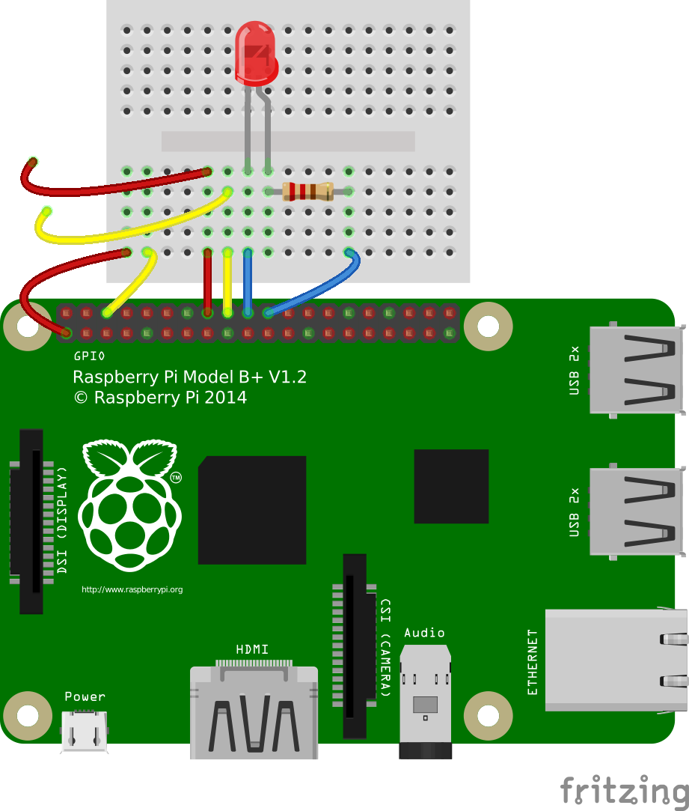

import RPi.GPIO as GPIO ## Import GPIO library
import time
GPIO.setmode(GPIO.BOARD) ## Use board pin numbering
GPIO.setup(16, GPIO.IN, pull_up_down=GPIO.PUD_DOWN)
#PUD_DOWN = na 3.3V
GPIO.setup(18, GPIO.IN, pull_up_down=GPIO.PUD_UP)
#PU_UP = na zem
GPIO.setup(22, GPIO.OUT) ## Setup GPIO Pin 22 to OUT
while 1:
if (GPIO.input(16) == 0):
print "Nic se nedeje"
GPIO.output(22, False)
time.sleep(0.2)
else:
# When the button switch is not pressed, turn off the LED.
print "Nekdo prisel, svitime!"
GPIO.output(22, True)
time.sleep(0.2)
if (GPIO.input(18) == 0):
print "Osmnactka jede"
time.sleep(0.2)

Ale jak na to, abych hledal změnu stavu? Ale čekám na to, až se mi - jedna podmínka za druhou splní…. fuj

SPINAC3.PY

import RPi.GPIO as GPIO ## Import GPIO library
import time
GPIO.setmode(GPIO.BOARD) ## Use board pin numbering
GPIO.setup(18, GPIO.IN, pull_up_down=GPIO.PUD_UP)
GPIO.setup(16, GPIO.IN, pull_up_down=GPIO.PUD_DOWN)
while 1:
GPIO.wait_for_edge(16, GPIO.RISING) # cekam a cekam….
print("Button 1 Pressed")
GPIO.wait_for_edge(16, GPIO.FALLING)
print("Button 1 Released")
GPIO.wait_for_edge(18, GPIO.FALLING)
print("Button 2 Pressed")
GPIO.wait_for_edge(18, GPIO.RISING)
print("Button 2 Released")
GPIO.cleanup()

Ale teď už fakt raději správně:
použijeme callback a bounce time 300ms?

SPINAC4.PY

import RPi.GPIO as GPIO
GPIO.setmode(GPIO.BOARD)
GPIO.setup(16, GPIO.IN, pull_up_down = GPIO.PUD_DOWN)
GPIO.setup(18, GPIO.IN, pull_up_down = GPIO.PUD_UP)
def printFunction(channel):
print("Button 1 pressed")
print("Note how the bouncetime affects the button press")
GPIO.add_event_detect(16, GPIO.RISING, callback=printFunction, bouncetime=300)
while True:
GPIO.wait_for_edge(18, GPIO.FALLING)
print("Button 2 Pressed")
GPIO.wait_for_edge(18, GPIO.RISING)
print("Button 2 Released")
GPIO.cleanup()

takže přístě:

SPINAC5.PY

import RPi.GPIO as GPIO
import time
GPIO.setmode(GPIO.BOARD)
GPIO.setup(16, GPIO.IN, pull_up_down = GPIO.PUD_DOWN)
GPIO.setup(18, GPIO.IN, pull_up_down = GPIO.PUD_UP)
def sestnactka(channel):
print("Sestnactka - Button "), channel
def osmnactka(channel):
print("Osmnactka - Button "), channel
GPIO.add_event_detect(16, GPIO.RISING, callback=sestnactka, bouncetime=300)
GPIO.add_event_detect(18, GPIO.FALLING, callback=osmnactka, bouncetime=300)
while True:
print time.ctime()
time.sleep(2)
GPIO.cleanup()

