PIR Cidlo

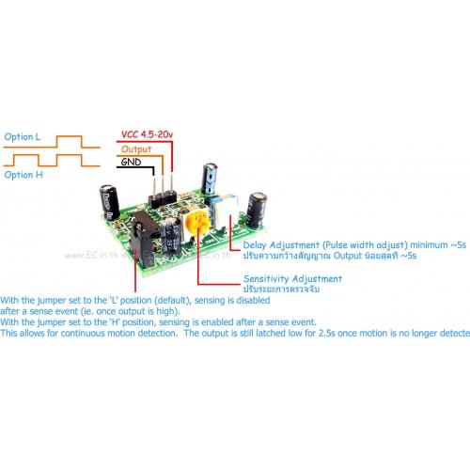

Delay nastvit na minimum

Citlivost na polovic

http://www.raspberrypi-spy.co.uk/2013/02/cheap-pir-sensors-and-the-raspberry-pi-part-2/

http://www.cmprogrammers.com/post.php?data=2014-08-05+20:38:00

wget http://www.cmprogrammers.com/projects/documents/alarm.py
wget http://www.cmprogrammers.com/projects/documents/uz.sh

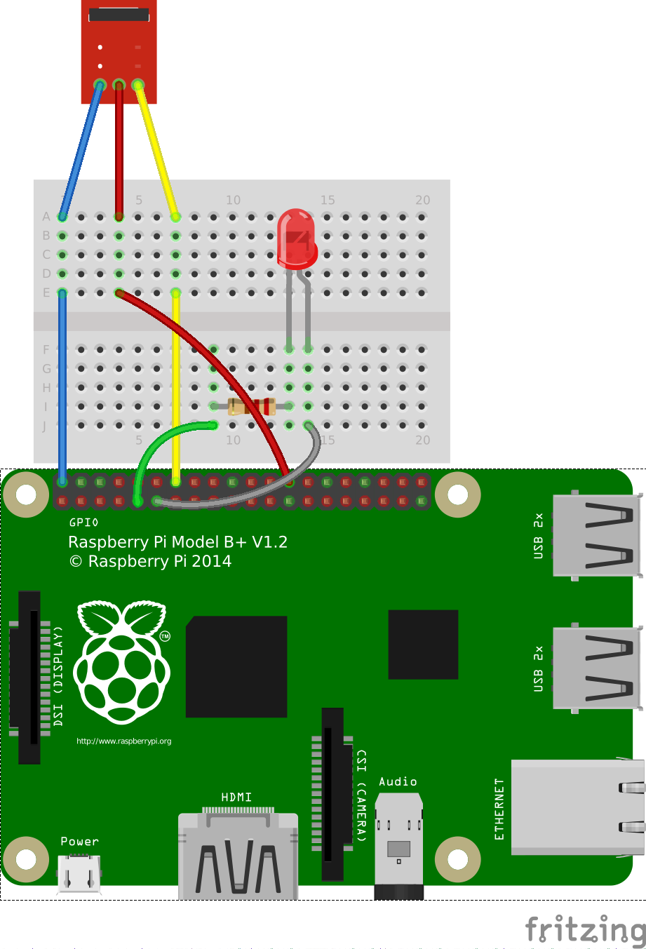

import RPi.GPIO as GPIO
import time
# Use BCM GPIO references
# instead of physical pin numbers
GPIO.setmode(GPIO.BCM)
# Define GPIO to use on Pi
GPIO_PIR = 7
GPIO_LED = 17
print "PIR Module Test (CTRL-C to exit)"
# Set pin as input
GPIO.setup(GPIO_PIR,GPIO.IN) # Echo
GPIO.setup(GPIO_LED,GPIO.OUT)
Current_State = 0
Previous_State = 0
GPIO.output(GPIO_LED,True)
time.sleep(2)
GPIO.output(GPIO_LED,False)
try:
print "Waiting for PIR to settle ..."
# Loop until PIR output is 0
while GPIO.input(GPIO_PIR)==1:
Current_State = 0
print " Ready"
# Loop until users quits with CTRL-C
while True :
# Read PIR state
Current_State = GPIO.input(GPIO_PIR)
if Current_State==1 and Previous_State==0:
# PIR is triggered
print " Motion detected!"
print time.ctime()
GPIO.output(GPIO_LED,True)
# Record previous state
Previous_State=1
elif Current_State==0 and Previous_State==1:
# PIR has returned to ready state
print " Ready"
GPIO.output(GPIO_LED,False)
Previous_State=0
# Wait for 20 milliseconds
time.sleep(0.02)
except KeyboardInterrupt:
print " Quit. Cleaning up GPIOs"
GPIO.cleanup()

