LEDna na PINu 16 a GROUND:

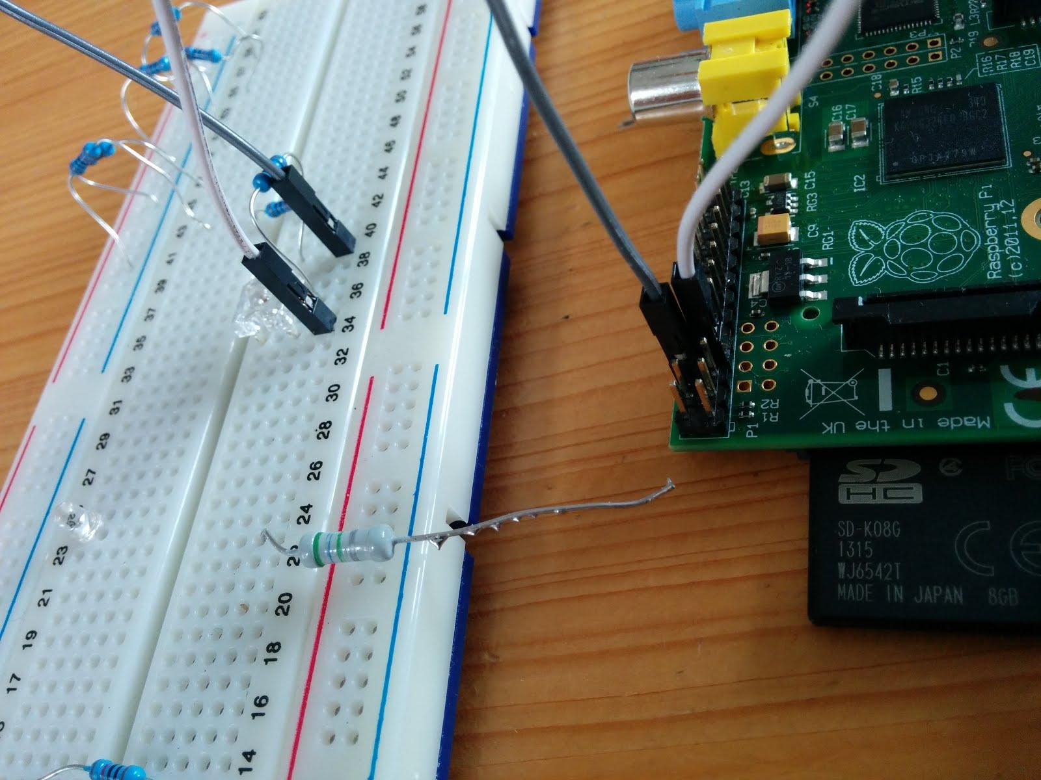
import RPi.GPIO as GPIO ## Import GPIO library
import time

GPIO.setmode(GPIO.BOARD) ## Use board pin numbering
GPIO.setup(16, GPIO.OUT) ## Setup GPIO Pin 16 to OUT

for x in xrange (3):
time.sleep(0.2)
GPIO.output(16,True) ## Turn on GPIO pin 16
time.sleep(0.2)
GPIO.output(16,False) ## Turn off GPIO pin 16
for x in xrange (3):
time.sleep(0.2)
GPIO.output(16,True) ## Turn on GPIO pin 16
time.sleep(0.8)
GPIO.output(16,False) ## Turn off GPIO pin 16
for x in xrange (3):
time.sleep(0.2)
GPIO.output(16,True) ## Turn on GPIO pin 16
time.sleep(0.2)
GPIO.output(16,False) ## Turn off GPIO pin 16
