Mereni vlhkosti DHT11 (dve verze)

https://learn.adafruit.com/dht-humidity-sensing-on-raspberry-pi-with-gdocs-logging/overview

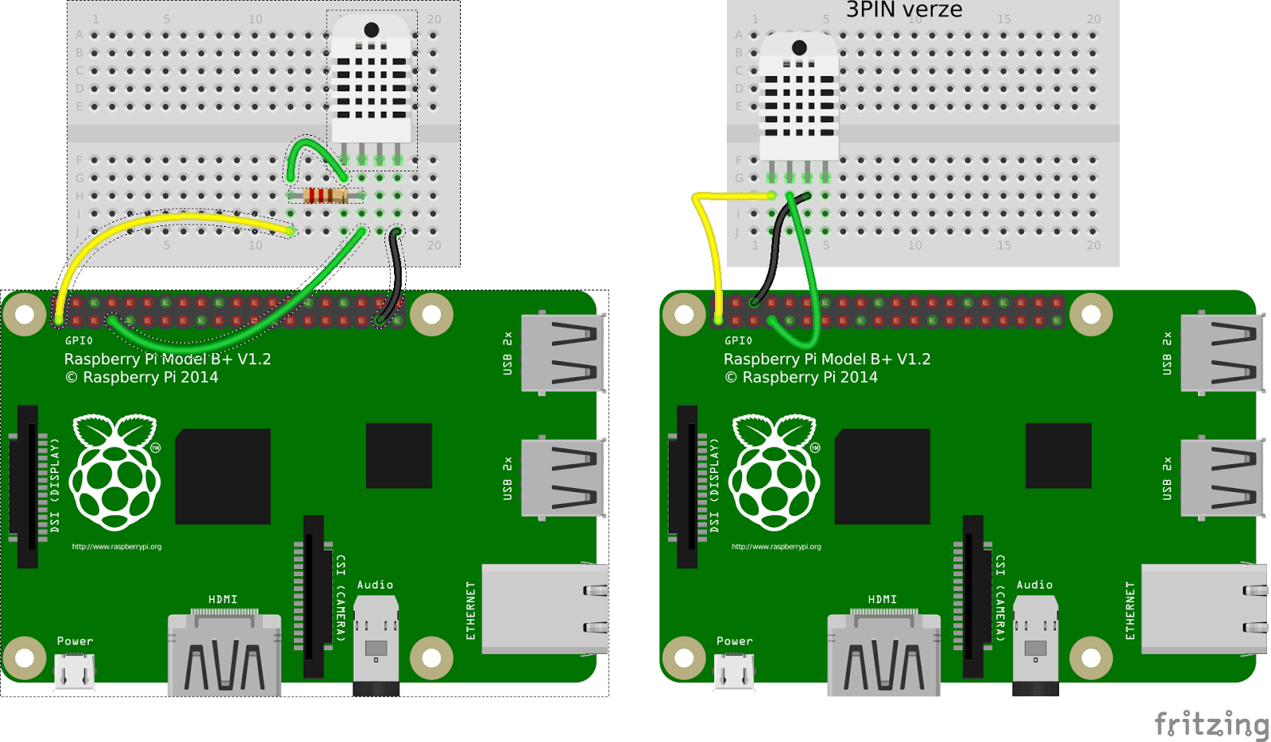

PYTHON
import RPi.GPIO as GPIO
import time

def bin2dec(string_num):
return str(int(string_num, 2))

data = []

GPIO.setmode(GPIO.BCM)

GPIO.setup(4,GPIO.OUT)
GPIO.output(4,GPIO.HIGH)
time.sleep(0.025)
GPIO.output(4,GPIO.LOW)
time.sleep(0.02)

GPIO.setup(4, GPIO.IN, pull_up_down=GPIO.PUD_UP)

for i in range(0,500):
data.append(GPIO.input(4))

bit_count = 0
tmp = 0
count = 0
HumidityBit = ""
TemperatureBit = ""
crc = ""

try:
while data[count] == 1:
tmp = 1
count = count + 1

for i in range(0, 32):
bit_count = 0

while data[count] == 0:
tmp = 1
count = count + 1

while data[count] == 1:
bit_count = bit_count + 1
count = count + 1

if bit_count > 3:
if i>=0 and i<8:
HumidityBit = HumidityBit + "1"
if i>=16 and i<24:
TemperatureBit = TemperatureBit + "1"
else:
if i>=0 and i<8:
HumidityBit = HumidityBit + "0"
if i>=16 and i<24:
TemperatureBit = TemperatureBit + "0"

except:
print "ERR_RANGE"
exit(0)

try:
for i in range(0, 8):
bit_count = 0

while data[count] == 0:
tmp = 1
count = count + 1

while data[count] == 1:
bit_count = bit_count + 1
count = count + 1

if bit_count > 3:
crc = crc + "1"
else:
crc = crc + "0"
except:
print "ERR_RANGE"
exit(0)

Humidity = bin2dec(HumidityBit)
Temperature = bin2dec(TemperatureBit)

if int(Humidity) + int(Temperature) - int(bin2dec(crc)) == 0:
print "Humidity:"+ Humidity +"%"
print "Temperature:"+ Temperature +"C"
else:
print "ERR_CRC"

Celej python kod je nestabilni.

python AdafruitDHT.py 11 4

11 typ cidla
4 GPIO (BCM)

Co treba pouzit rozumny kod a navic data rvat do Google Tabulky?
Mrk na

https://docs.google.com/spreadsheets/d/1aVZZY_qGac6p1JsgA8761cXx39GJzHiCMDA6faMCA0U/edit#gid=0

